|  |
| --- |
| . |
| Implant Training |
| . |

|  |
| --- |
| BY;A. AKSHAY RAJ SINGH(17BD1A0463)  [Pick the date] |

Implant Training

Let us first know what is implant training

**Implant training** provides the industrial exposure to the students how to face the industry once they foot out from the campus. The industrial knowledge is essential for all students to get success in their job.

As we have been introduced about the implant training now let us know about the machines available in CITD in detail with some of the pictures.

Starting with the

Flower pot making machine,

**Flower Pots Making Machines**areused to make special-shape articles which are been used in making crackers and the machine here in CITD provides a large number of flower pots to the standard fireworks,this machine has grabbed such a huge attention just because of its  newly and ideal equipment for manufacturers.

Given below is the photo for the flower pots manufacturing machine and also with the sample .

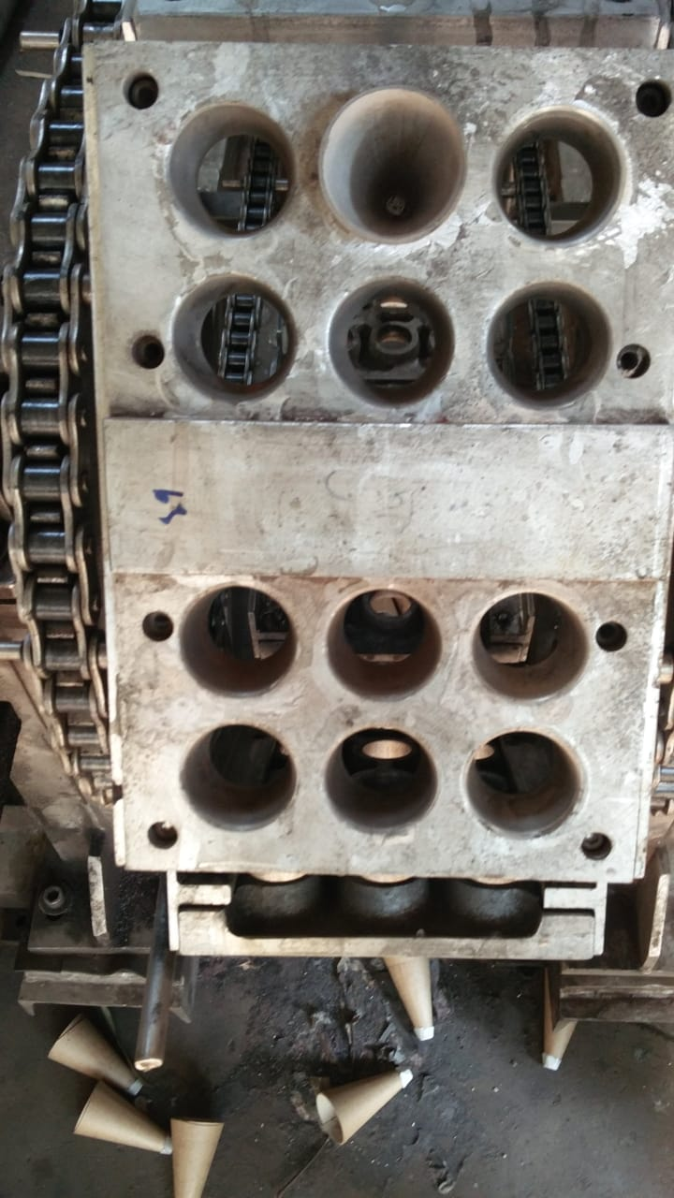 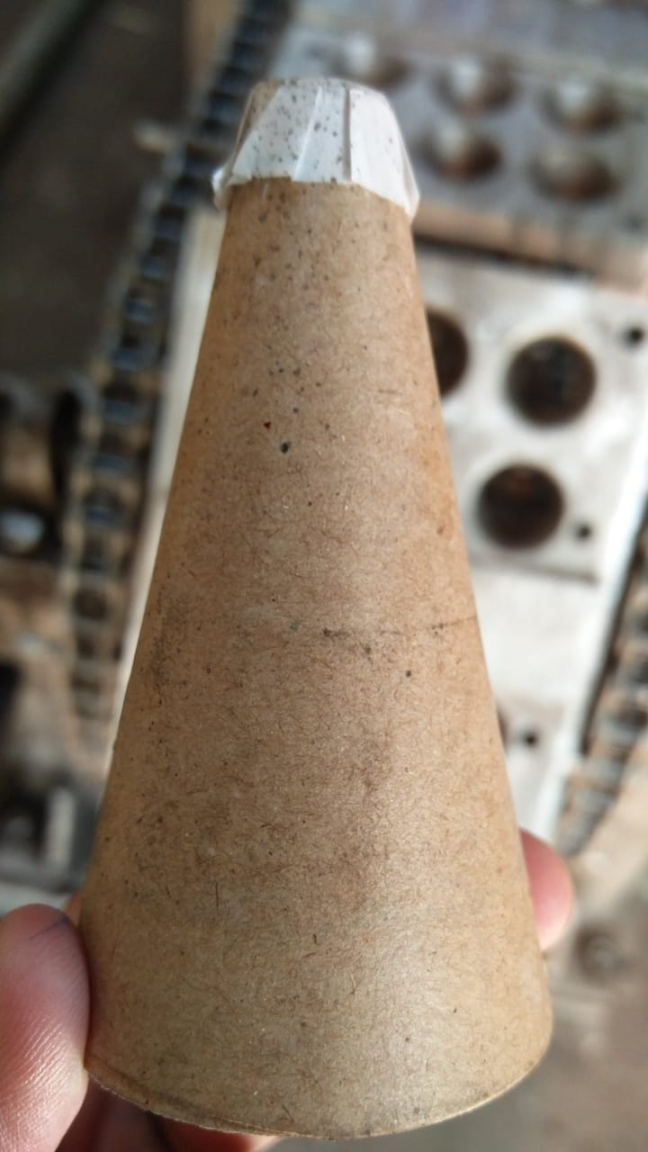

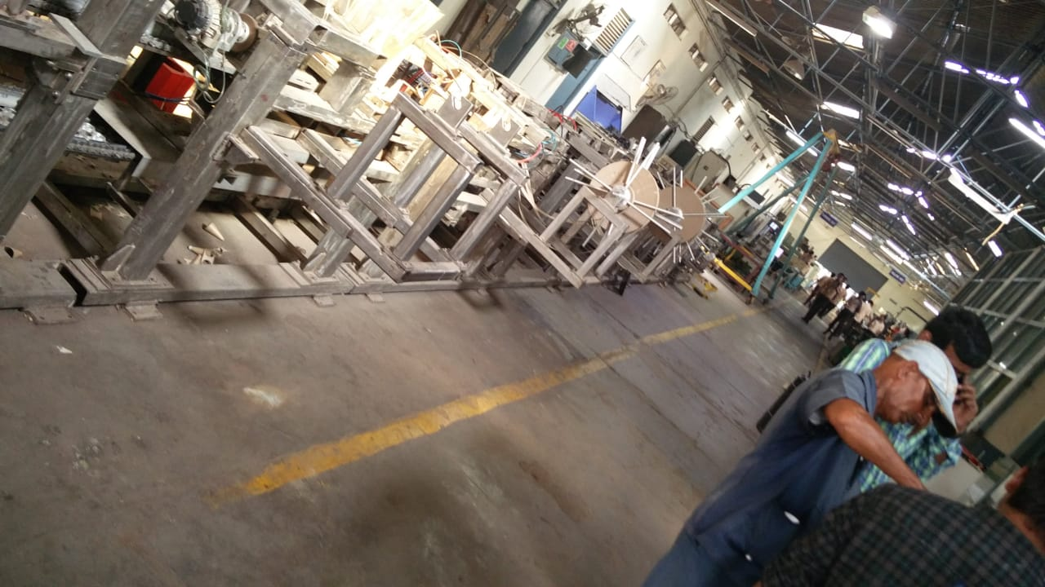

CNC milling

**Milling** is the process of cutting and drilling material (like wood or metal). A **milling machine**, regardless of whether it's operated manually or through **CNC**, **uses** a rotating cylindrical tool called a **milling** cutter.

**CNC milling** is a certain type of **CNC** machining. **Milling** is a process that is quite similar to drilling or cutting, and **milling** can perform these processes for a variety of production needs. ... **CNC** mills are often grouped by the number of axes on which they can operate. Each axis is labeled using a specific letter.

## Nearly all types of materials that can physically be drilled or cut can be manipulated by CNC mills. However, most CNC mill machines work with metal materials. Much like the processes of drilling and cutting, the appropriate CNC machine tools have to be chosen for each material being used. The density of the material at-hand, along with the rotation of the cutting tool, must be considered prior to starting the milling production process.

In general,C mills are very efficient when it comes to prototyping, the short-run production of complex parts, and the fabrication of precision parts and components. But these powerful machines offer a wide range of other benefits, particularly in terms of manipulating most materials in a very efficient manner. Manual mills are still around.

The picture given are of cnc milling machines.

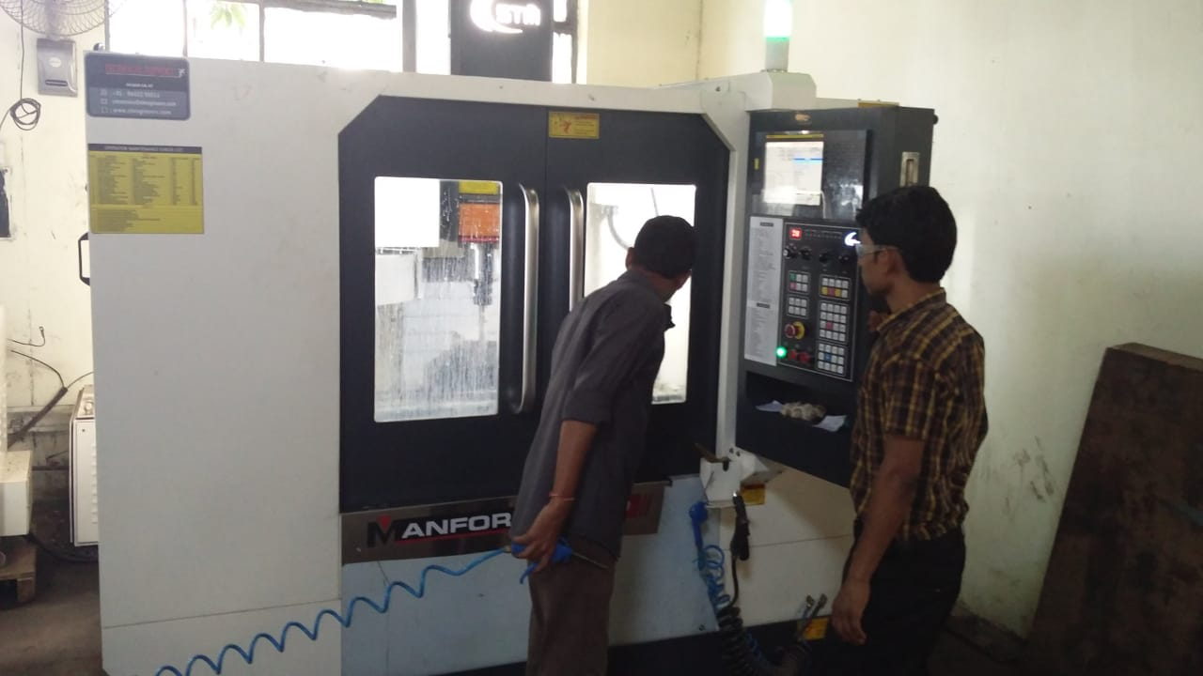

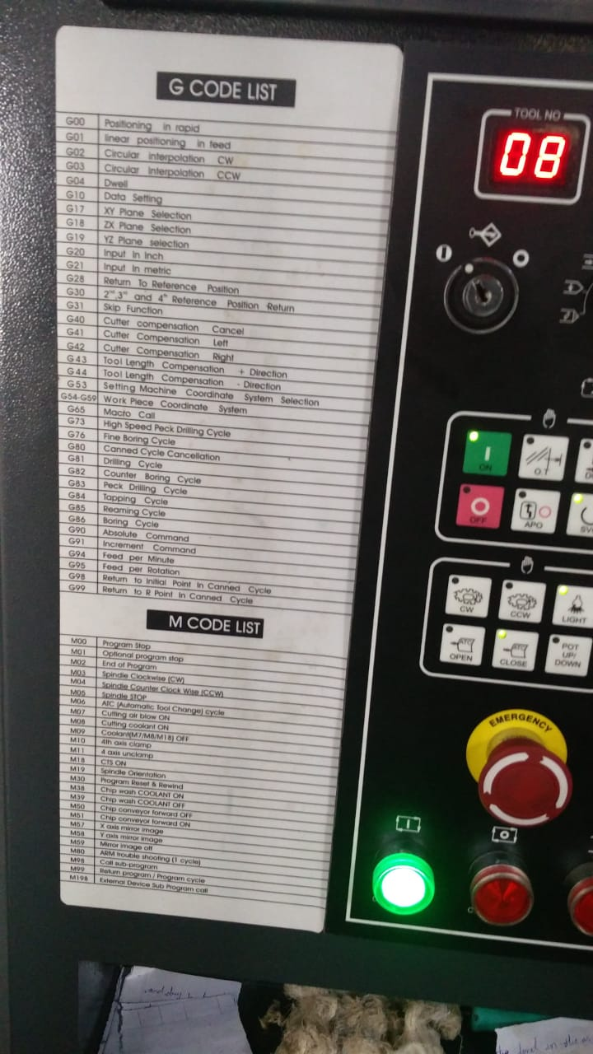

EDM wire cutting Machine

**Wire Cut EDM** (Electrical Discharge Machining) Electrical discharge machining (**EDM**) is a process of metal machining in which a tool discharges thousands of sparks to a metal workpiece. ... Instead of **cutting** the material, **EDM** melts or vaporizes it, leaving little debris and providing a very accurate line.

When using standard 0.010" O brass **wire** you can expect a consistent, reliable **wire EDM cutting** speed of approximately eighteen to twenty inch}/hour. Unfortunately, the **EDM** process creates minute chips and debris that can adversely affect the reliability of this transport system.  **EDM accuracy** depends on a combination of workpiece characteristics, the surface finish desired, and the time available for machining.

Because of its versatility, manufacturers us wire cut EDM functions for an extensive range of applications. Because the process can cut very small pieces, it is often an ideal choice for the production of small, highly detailed items that would normally be too delicate for other machining options. Additionally, the process is cost effective for low quantity projects, and can prove to be beneficial in prototype manufacturing, even if the actual project is carried out by different means.   
    
It is important to remember that the wire in the process is constantly moving, and not to be reused. As a result, the copper, brass or other metallic wire can be kilometers long, adding to the cost.

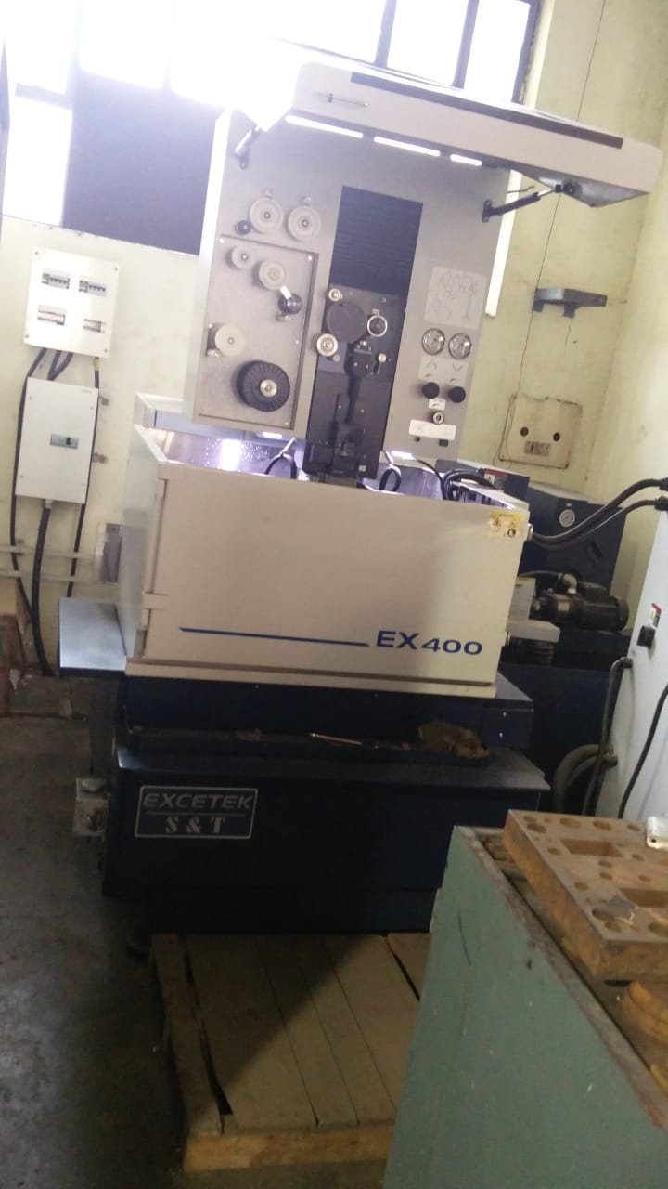

LATHE MACHINE

The main function of a **lathe** is to remove metal from a piece of work to give it the required shape and size.This is accomplished by holding the work securely and rigidly on the **machine** and then turning it against a cutting tool which will remove metal from the work in the form it is a [machine tool](https://en.wikipedia.org/wiki/Machine_tool) that rotates a workpiece about an [axis of rotation](https://en.wikipedia.org/wiki/Axis_of_rotation) to perform various operations such as [cutting](https://en.wikipedia.org/wiki/Cutting), [sanding](https://en.wikipedia.org/wiki/Sanding), [knurling](https://en.wikipedia.org/wiki/Knurling), [drilling](https://en.wikipedia.org/wiki/Drilling), [deformation](https://en.wikipedia.org/wiki/Deformation_(engineering)), [facing](https://en.wikipedia.org/wiki/Facing_(machining)), and [turning](https://en.wikipedia.org/wiki/Turning), with tools that are applied to the workpiece to create an object with [symmetry](https://en.wikipedia.org/wiki/Rotational_symmetry) about that axis.

The lathe is an ancient tool. The earliest evidence of a lathe dates back to [Ancient Egypt](https://en.wikipedia.org/wiki/Ancient_Egypt) around 1300 BC.[[2]](https://en.wikipedia.org/wiki/Lathe#cite_note-2) There is also tenuous evidence for its existence at a Mycenaean Greek site, dating back as far as the 13th or 14th century BC.[[3]](https://en.wikipedia.org/wiki/Lathe#cite_note-3)

Clear evidence of turned artifacts have been found from the 6th century BC: fragments of a wooden bowl in an [Etruscan](https://en.wikipedia.org/wiki/Etruscan_civilization) tomb in Northern Italy as well as two flat wooden dishes with decorative turned rims from [modern Turkey](https://en.wikipedia.org/wiki/Asia_Minor).[[4]](https://en.wikipedia.org/wiki/Lathe#cite_note-4)

During the [Warring States period](https://en.wikipedia.org/wiki/Warring_States_period) in [China](https://en.wikipedia.org/wiki/China), ca 400 BCE, the ancient Chinese used rotary lathes to sharpen tools and weapons on an industrial scale. [[5]](https://en.wikipedia.org/wiki/Lathe#cite_note-5)

The first known painting showing a lathe dates to the 3rd century BC in [ancient Egypt](https://en.wikipedia.org/wiki/Ancient_Egypt).[[6]](https://en.wikipedia.org/wiki/Lathe#cite_note-6)

The lathe was very important to the [Industrial Revolution](https://en.wikipedia.org/wiki/Industrial_Revolution). It is known as the *mother of machine tools*, as it was the first machine tool that led to the invention of other machine tools.[[7]](https://en.wikipedia.org/wiki/Lathe#cite_note-7) The first fully documented, all-metal slide rest lathe was invented by [Jacques de Vaucanson](https://en.wikipedia.org/wiki/Jacques_de_Vaucanson) around 1751. It was described in the [Encyclopédie](https://en.wikipedia.org/wiki/Encyclop%C3%A9die" \o "Encyclopédie).

[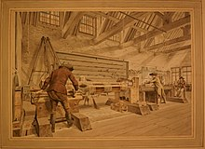](https://en.wikipedia.org/wiki/File:Jan_Verbruggen_Foundry_Drawing_47_Horizontal_Boring_Machine.jpg)

Exact drawing made with [camera obscura](https://en.wikipedia.org/wiki/Camera_obscura) of horizontal boring machine by Jan Verbruggen in Woolwich Royal Brass Foundry approx. 1778 (drawing 47 out of set of 50 drawings)

An important early lathe in the UK was the horizontal boring machine that was installed in 1772 in the [Royal Arsenal](https://en.wikipedia.org/wiki/Royal_Arsenal) in [Woolwich](https://en.wikipedia.org/wiki/Woolwich). It was horse-powered and allowed for the production of much more accurate and stronger cannon used with success in the [American Revolutionary War](https://en.wikipedia.org/wiki/American_Revolutionary_War) in the late 18th century. One of the key characteristics of this machine was that the workpiece was turning as opposed to the tool, making it technically a lathe. [Henry Maudslay](https://en.wikipedia.org/wiki/Henry_Maudslay) who later developed many improvements to the lathe worked at the Royal Arsenal from 1783 being exposed to this machine in the Verbruggen workshop.[[8]](https://en.wikipedia.org/wiki/Lathe#cite_note-8) A detailed description of Vaucanson's lathe was published decades before Maudslay perfected his version. It is likely that Maudslay was not aware of Vaucanson's work, since his first versions of the slide rest had many errors that were not present in the Vaucanson lathe.

During the [Industrial Revolution](https://en.wikipedia.org/wiki/Industrial_Revolution), mechanized power generated by water wheels or [steam engines](https://en.wikipedia.org/wiki/Steam_engines) was transmitted to the lathe via line shafting, allowing faster and easier work. Metalworking lathes evolved into heavier machines with thicker, more rigid parts. Between the late 19th and mid-20th centuries, individual electric motors at each lathe replaced line shafting as the power source. Beginning in the 1950s, [servomechanisms](https://en.wikipedia.org/wiki/Servomechanism) were applied to the control of lathes and other machine tools via numerical control, which often was coupled with computers to yield computerized numerical control (CNC). Today manually controlled and CNC lathes coexist in the manufacturing industries.

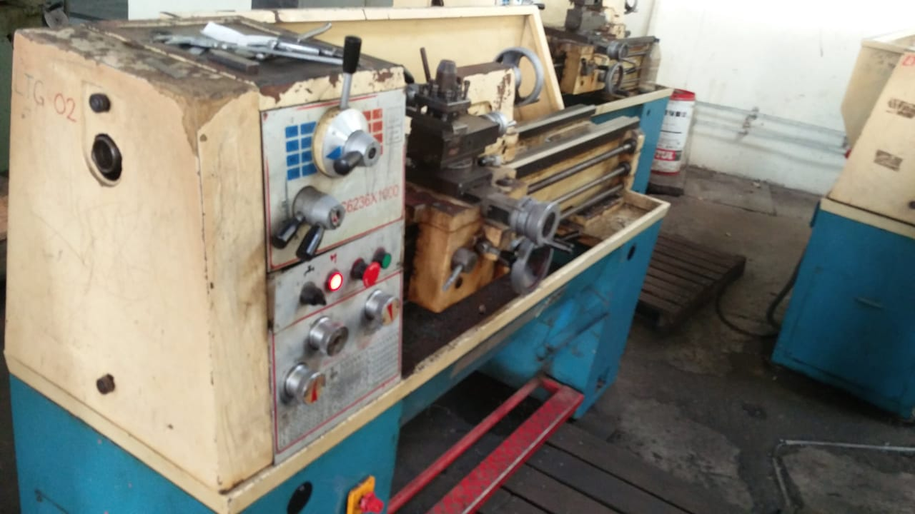

Cue lathes function similarly to turning and spinning lathes, allowing a perfectly radially-symmetrical cut for [billiard cues](https://en.wikipedia.org/wiki/Cue_stick). They can also be used to refinish cues that have been worn over the years.

Tool and Cutter Grinding

A **tool and cutter grinder** is used to sharpen [milling cutters](https://en.wikipedia.org/wiki/Milling_cutter) and [tool bits](https://en.wikipedia.org/wiki/Tool_bit) along with a host of other cutting tools.

It is an extremely versatile machine used to perform a variety of grinding operations: surface, cylindrical, or complex shapes. The image shows a manually operated setup, however highly automated Computer Numerical Control ([CNC](https://en.wikipedia.org/wiki/CNC)) machines are becoming increasingly common due to the complexities involved in the process.

The operation of this machine (in particular, the manually operated variety) requires a high level of skill. The two main skills needed are understanding of the relationship between the grinding wheel and the metal being cut and knowledge of tool geometry. The illustrated set-up is only one of many combinations available. The huge variety in shapes and types of machining cutters requires flexibility in usage. A variety of dedicated fixtures are included that allow [cylindrical grinding](https://en.wikipedia.org/wiki/Cylindrical_grinder) operations or complex angles to be ground. The vise shown can swivel in three planes.

The table moves longitudinally and laterally, the head can swivel as well as being adjustable in the horizontal plane, as visible in the first image. This flexibility in the head allows the critical clearance angles required by the various cutters to be achieved.

A radius grinder (or radius tool grinder) is a special grinder used for grinding the most complex tool forms, and is the historical predecessor to the CNC tool and cutter grinder. Like the CNC grinder, it may be used for other tasks where grinding spherical surfaces is necessary. The tool itself consists of three parts: The grinder head, work table, and holding fixture. The grinder head has three degrees of freedom. Vertical movement, movement into the workpeice, and tilt. These are generally set statically, and left fixed throughout operations. The work table is a T-slotted X-axis table mounted on top of a radial fixture. Mounting the X axis on top of the radius table, as opposed to the other way around, allows for complex and accurate radius grinds. The holding fixtures can be anything one can mount on a slotted table, but most commonly used is a collet or chuck fixture that indexes and has a separate Y movement to allow accurate depth setting and endmill sharpening. The dressers used on these grinders are usually quite expensive, and can dress the grinding wheel itself with a particular radius.

